Recliner Boy

The Recliner Boy Project
Evan Mcdowell, RIC
Shirley Bochman
Joseph Phan
Matthew Turpin

Northwestern Un
iversity, Engineering Design and Communication
Section 13
Team 1
Penny Hirsch
Henry Stoll Jr.
March 11, 2006

Table of Contents

Executive Summary…………………..…………………………….…….…...1
Introduction….………………………………………….………………..........2
Design Concept………………………………………………..........................3
Background Research…………………………………………………………5 Methods……………………………………………….…………….…5
Findings……………………………………………………………......5
Implications for alternatives……………………………………….......8
Alternatives…………………………………………………………………….9
Concepts………………………………………………………………..9
Testing…………………………………………………………….…..10
Evaluation……………………………………………………….…....12
Next Steps………………………………………………………………..…...13
Appendices……………………………………………………………….…...14
Appendix A: Project Definition………………………………………14
Appendix B: User Interview Guide……………………………...…..15
Appendix C: References………………………………………...…...16
List of Figures

Figure 1: The Recliner Boy........................................................................................................1
Figure 2: Current Leg Press at RIC............................................................................................2
Figure 3: Recliner boy at rest (left) and in raised position (right) .............................................3
Figure 4: The four types of leg presses......................................................................................5
Figure 5: Muscles worked by leg press......................................................................................6
Figure 6: From left to right, transfer board, NUSTEP, tri-pin grip, Versatrainer......................7
Figure 7: The ramp….................................................................................................................9
Figure 8: The recliner…............................................................................................................10
Figure 9: The wheel motor........................................................................................................10

List of Tables
Table 1: User comments and suggestions.................................................................................11
Table 2: User ratings of intuitiveness of design........................................................................11
Table 3: Decision Matrix..........................................................................................................12

Executive Summary

The leg press at the Rehabilitation Institute of Chicago must accommodate a wide range of users: people with spinal cord injuries that can still move their legs, stroke patients, the blind, amputees, and employees with no disabilities. Currently, many users have problems lifting their legs up from the floor to the platform and have problems maintaining their legs up on the platform. Therefore, some kind of foot maintenance system that would use a mechanism would be ideal.

This report introduces our design, the Recliner Boy, which fulfills the following requirements:
- Increases the accessibility of the leg press to users with weakened leg strength
- Increases user independence
- It is intuitive and safe for all users

The Recliner Boy functions like a lazy boy. It uses a powered mechanism to transfer the legs from the floor to the footplate. The device is accessible because the users do not have to lift their legs on their own.

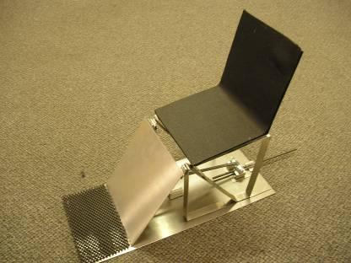
Figure 1: The Recliner Boy

Introduction

The leg press at the Rehabilitation Institute of Chicago (RIC) must accommodate a wide range of users: people with spinal cord injuries that can still move their legs, stroke patients, the blind, amputees, and employees with no disabilities. Currently, many of the RIC users have a difficult time raising their feet from the ground to the footplate (see Figure 1). Our team’s focus was to create a mechanism to facilitate this task.
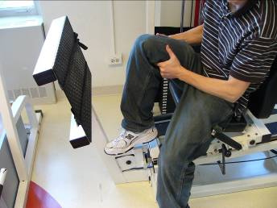
Figure 2: Current Leg Press at RIC

Leg press users have to overcome two obstacles to place their legs onto the footplate. The first is to get their legs over the bar at the base of the footplate. After that is accomplished, the users must then lift their legs to the plate. Both of these actions require the users to carry their legs physically with their hands. Many users also have to ask a physical therapist or a caregiver for assistance. Since the goal of the RIC is to encourage independence, this creates a problem.

This report introduces our design, the Recliner Boy, which fulfills the following requirements:
- It must increase the accessibility of the leg press to users with weakened leg strength
- It must increase user independence
- It must be intuitive and safe for all users

This report then describes our preliminary project research, concept generation, concept evaluation and steps to be taken in the future.

Design Concept

The Recliner Boy functions like a lazy boy. It uses a powered mechanism to transfer the legs from the floor to the footplate. The device is accessible because the users do not have to lift their legs on their own.

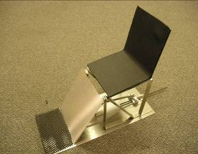
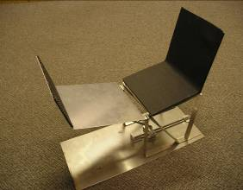
Motor
Motor
Figure 3: Recliner boy at rest (left) and in raised position (right)

Features

Electric Motor and Power Screw
The feature that makes the lazy boy unique is the mechanism that drives the feet upward. This design incorporates a 110 volt gear motor and power screw to drive the machine. (See Figure 2) The system is designed to provide a small rotational power over a long period of time to maximize the efficiency of the motor. This is accomplished though the intelligent placement of the slider/rod assembly which provides the upward force on the footplate (See Appendix A for design specifications). This gives the system a large mechanical advantage to lift the legs on the footplate. When we interviewed users at the RIC, many preferred the idea of a powered system, since they thought that mechanical solutions, like the lever on the mockup, would be difficult for users with limited arm strength (see Appendix B for user interview). As a result, we hybridized the two mockups into the power screw on the Lazy Recliner.

Rotating Lifting Platform
The path the footplate travels is also an important feature. The Recliner Boy uses a curvilinear motion that closely mimics the natural motion of the knee joint and lower leg. This will ensure that all users who have limited leg strength will avoid problems with the machine exerting abnormal forces and will prevent injury.

Accessible Buttons
Another feature important to the design is the easy-to-use buttons. User testing revealed that users prefer the use of buttons to lift the footplate due to their simplicity and ease of use.

Benefits
There are many benefits to the Recliner Boy. The Recliner Boy is easy to transfer into for users in wheelchairs. This makes it more accessible for users at the RIC. Because of the electric lift, the Recliner Boy’s operation is simple and intuitive. In addition, the lift makes the footplate adjustable to fit the users’ height preferences. The ergonomic shape of the machine closely imitates the motion of the human body, which will promote safe egress.

Background Research

Methods

Client Meeting

We had a client meeting on January 17, 2006, with Evan McDowell, a physical therapist from the Rehabilitation Institute of Chicago. He told us who uses the machine and the current problems the machine poses for its users.

Web Research

In order to learn more about typical leg presses and which muscles they exercise as well as current machines specifically catering to persons with disabilities, we investigated a number of reputable resources. Dolfzine online fitness magazine and consumersearch.com were among the sites visited (see Appendix C for entire listing).

User Observations

We observed and interviewed a user at the RIC exercise gym in Abbott Hall on January 26, 2006. We learned information about the transfer, lifting of legs, and exchanging weights, and learned which solutions would be most practical to implement.

Findings

All leg press machines are similar in cost. They range from $500 to $3000, depending on features and brand name. We found four different types of leg presses varying on safety and design.
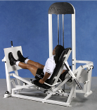
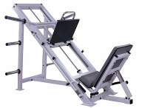
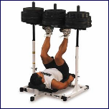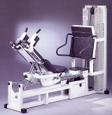
Figure 4: The four types of leg presses
Source: Dolfzine Online Fitness Magazine (http://www.dolfzine.com)
Types of Machines
- Vertical leg press
  - Pros: Simple
  - Cons: Dangerous, small range of motion, little adjustability
- Horizontal leg press
  - Pros: Stable and safe
  - Cons: Force is distributed through hips and back
- 45 degree leg press
  - Pros: Safer than vertical and horizontal leg presses, easier to transfer into
  - Cons: Weights still pressed down on user, the seat is not upright
- Seated leg press
  - Pros: The seat is upright, safest and easiest to get into
  - Cons: Complicated design, lots of cables

It is important to exercise lower body muscles because they are necessary to properly execute the standing motion. The leg press works two key areas and three muscles of the lower body.
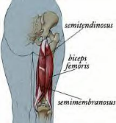
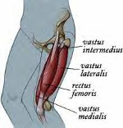
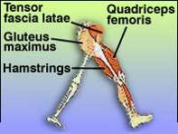
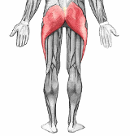
Figure 5: Muscles worked by leg press
Source: Fitness Online (http://www.fitness-center.at/)

Muscles worked by leg press
- Hip joint area
  - Hamstrings (biceps femoris)
  - Gluteus maximus
- Knee joint area
  - Quadriceps

We found a number of safety measures to be taken while using the leg press to avoid injury.

Safety precautions
- User Must
  - Maintain a greater than 90 degree angle
  - Not completely extend their legs
  - Not exceed their capabilities
  - Remain seated, with black flush against pad
  - Use both heel and forefoot in extension of the legs

These machines concern wheelchair to leg press transfers, gripping problems, and wheelchair seat stabilizers.

Machines catering to persons with disabilities

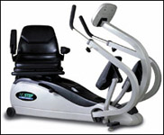
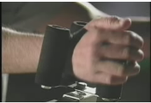
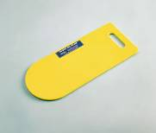
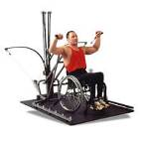
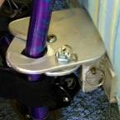

Figure 6: From left to right, transfer board, NUSTEP, tri-pin grip, seat stabilizer, Versatrainer
Source: Versatrainer (http://www.bowflex.com)
- Adaptations for machines for people with disabilities
  - Transfer board
    - Angled
    - Flat
    - Slide along from surface to surface
  - NUSTEP
    - Swivel seat
    - Wide, comfortable seat
    - Easily adjustable seat
- Gripping problem machines
  - Uppertone
    - Tri-pin system
      - Eliminates gripping, screws one side to other
    - Variable resistance
      - Move weight along bar
- Stabilization Device
  - Seat stabilizer
    - Bolts against wall
    - Prevents from moving
    - Easy to use
  - Versatrainer
    - Rubber hoses attached to base

Implications for Alternatives

Our research findings had implications for three aspects of our alternative concepts:

Mechanical Assistance: User observations showed that the users have problems lifting their legs up from the floor to the platform. Therefore, some kind of mechanical assistance would be ideal, such as traction ropes, conveyor belts, or a La-Z-Boy hinge plate.

Foot Maintenance: User observations revealed that users have problems maintaining their legs up on the platform. Therefore, some kind of foot maintenance system would be ideal, such as a shifting foot clamp or ski boot clamps.

Safety: Background research showed that there are safety features that we needed to consider when designing the leg press. The legs cannot be bent past 90 degrees. Additionally, the legs need to follow a path that mimics the natural motion of the human body.
Alternative Designs

Concepts

In this section, we describe what alternatives we considered in designing the Recliner Boy.

Following are the questions we tried to answer with our alternative mockups:

Is the design intuitive?
An important specification is to maximize user independence. We needed to create a design that is intuitive. That way, it could be used with as little explanation as possible.

Would the mockup function as planned?
We recognized that our mockups were made out of foamcore, making it difficult to determine if the models would actually work, but we needed to determine if the concept had a chance at functionality.

What kind of design would the user prefer?
Would the users prefer a design with a motor, one where they could use a recliner-like device to lift their legs, or one where it would be easier to use their leg muscles?

To answer these questions, we developed three alternatives which we mocked up for user testing.

Alternative 1 – The ramp concept. This alternative uses an incline plane to lift the leg over the bar and a curved walk up plane to reach the foot platform. This curved walk up plane mimics the curvilinear motion of the human leg. Users must push against the curved surface as they shimmy up to the correct position.
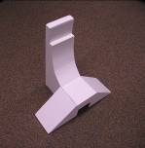
Figure 7: The ramp

Alternative 2 – The recliner concept. In this design the foot platform is already on the floor and a lever system raises the legs and platform together to the appropriate height for exercise. The user sits in the chair and pulls a lever to move the machine to the appropriate position.
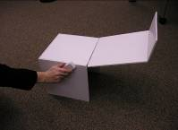
Figure 8: The recliner
Alternative 3 – The wheel-motor concept. This uses a complex system of gears and levers to rotate the footplate into position. The user pushes a button to turn the wheel and lift his or her legs and footplate into the appropriate height for exercise.
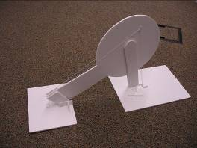
Figure 9: The wheel motor

Testing

Test Methods

We did user testing at the Rehabilitation Institute of Chicago on February 16, 2006. We interviewed three potential users and asked them questions (See the Interview Guide in Appendix B) about accomplishing these tasks:

- Verify the intuitiveness of the design
- Determine the convenience of the design
- Analyze its functionality

Tables 1 and 2 summarize user comments and suggestions

Table 1: User comments and suggestions
Model | Comments | Suggestions
Ramp | Difficult to use with different size legs | Make the seat move easily
 | Very simple
 | Low upkeep
Recliner | Easy entry
 | Might be difficult for users without full arm strength | Put a motor on recliner
 | Lever is intuitive
Wheel/Motor | Aesthetically pleasing
 | Confused about functionality and footplate rotation | Clearly label buttons and motor
 | Like motor concept

Table 2: User ratings of intuitiveness of design
Mockup Model | User 1 | User 2 | User 3
Ramp | 2 | 4 | 4
Recliner | 5 | 5 | 3
Wheel/Motor | 1 | 3 | 3

Key: 1 = not clear
5 = extremely clear
Evaluation

Alternatives Evaluation

We used a decision matrix to identify essential features of the mockups.
Table 3: Decision matrix
 | Ramp | Recliner | Wheel/Motor
Intuitiveness | + | ++ | --
Accessibility | + | 0 | +
Convenience | - | + | ++
Safety | + | 0 | -
TOTAL | 3+ | 3+ | 0

KEY
-- = Does not satisfy criterion at all
- = Does not satisfy criterion
+ = Satisfies criterion
++ = Satisfies criterion extremely well
0 = Neutral

Based on the decision matrix, the recliner and the ramp have the same score. Rather than use one of these alternatives or eliminate the third idea entirely, we decided to combine the best aspects of the alternatives to create the best design. The motor from the wheel design would power the recliner to improve its convenience score. Therefore, the user would not need significant arm strength to get his or her legs in position. This was one of the suggestions the users had, and we thought it was an excellent idea.
Next Steps

This report is a proof of concept of the Recliner Boy. There are aspects of the design that we are unable to investigate and fund in order to bring the concept to completion. The following is a list of concepts that still need to be addressed in order to construct a final design.

Mechanics
The current design has had insufficient analysis to maximize the mechanical advantage of the system. Questions to investigate include:

- What are the best angles to use to maximize performance?
- What is the best power for the motor?
- What is the best threading for the screw?
- What are the best materials for constructing the device?

Safety
The motor will not be smart enough to know if the user is having difficulties while the machine is moving, and the joint between the pivot and the rod might have a pinch point that will need to be fixed. Questions to investigate include:

- How will the machine recognize or prevent stress on legs?
- How will the joint be constructed to prevent pinching?
- What will cover the joint to prevent pinching?

Comfort
The motor will also have to be chosen based on its speed. Questions to investigate include:

- Is there a range of speeds available to users?
- What are the speeds of the machine?

We hope that the RIC decides to continue the development we have begun on the Recliner Boy project and bring it through the entire development process to a final product.
Appendix A: Project Definition

Project Name: Accessible Leg Press

Client: Evan Mcdowell

Team Members: Matt Turpin, Joe Phan, Shirley Bochman

Version: Two

Mission Statement: Our mission is to redesign/modify the life-fitness leg press at the Rehabilitation Institute of Chicago so that users with weakened leg strength can place their legs on the footpad.

Constraints:
- Must modify the existing leg press
- Any modifications must remain within a 3ft radius of the existing machine

Stakeholders:
- Clients
- Therapist/physicians of RIC
- Technicians/support staff
- Manufacturers
- End users

Requirements | Specifications
Accessibility  - User can put feet on platform without struggling.  - User can keep feet on platform easily.  - Requires less use of hands  - Needs less bending at waist  - More practical means for feet maintenance | - Must accommodate heights from 3 feet to 7 feet tall  - Must support torque of 1000 foot pounds
Ease of Use | - Must provide intuitive and simple understanding of use
Convenience  - User can get feet on platform independently  - Machine is designed to aid user | - Must lift legs in less than 10 seconds
Safety | - Knees bend in the range between 0 and 90 degrees
Appendix B: User Interview Guide

Hello, we are Matt Turpin, Joe Phan, and Shirley Bochman. We are engineering students at Northwestern University designing a modification to the current leg press here at the RIC. We are redesigning this leg press so that users with varied limitations can easily transfer their legs from the floor to the foot-platform of the leg press. We would like to show you a few design mockups, but first we’d like to get some background information about you.

Name:
Age:
Gender: M / F
Have you used a leg press before?
If no, why not?

If yes, how often?

What concerns do you have while exercising?

We’d like to show you a few ideas that we put together to see how well they perform. Again, we’re not testing you, we’re testing the machine – any problems are the machine’s fault. Please give us any and all feedback – good and bad. This feedback will help us redesign our ideas to make the machine better.

(Present first mockup – Ramp. Show where location of seat is)
- How would you use this machine (can you tell just by looking at it)? Explain.

(Explanation: First, you slide your feet up the ramp to the first platform. Next you walk your feet up the curved ramp and rest your feet on the ledge. From there push your feet to use the leg press.)

On a scale of 1-5, (1 = not clear at all, 5 = crystal) how self-explanatory is this design?

- Now that you know how to use this machine, would you actually use it? Why/why not?

- What do you like/dislike about the machine?

(Present second mockup – lazyboy. Show location of seat)
- How would you use this machine?

(Explanation: Put your feet on the indicated platform, pull the lever on either side to raise the platform to the correct position.)

On a scale of 1-5, (1 = not clear at all, 5 = crystal) how self-explanatory is this design?

- Now that you know how to use this machine, would you actually use it? Why/why not?

- What do you like/dislike about the machine?

(Present third mockup – wheel. Show where location of seat is.)
- How would you use this machine?

(Explanation: Put your feet on the indicated platform, and allow the wheel to raise the platform to the correct position.)

On a scale of 1-5, (1 = not clear at all, 5 = crystal) how self-explanatory is this design?

- Now that you know how to use this machine, would you actually use it? Why/why not?

- What do you like/dislike about the machine?

Which design would you prefer to use? Why?

Are there any features of any of the designs that you particularly like/dislike?
Appendix C: References

Leg press: Perfect Form (n.d.) Find Articles: Retrieved January 20, 2006 from http://www.findarticles.com/p/articles/mi_m0KGB/is_6_3/ai_98641177

Leg Presses (2003) Dolfzine Online Fitness: Retrieved January 20, 2006 from www.dolfzine.com/page611.htm

Versatrainer (2005) Bowflex: retrieved January 18, 2006 from http://www.bowflex.com/mMachineDetailVersa.asp?Domain=www%2Ebowflex%2Ecom&productID=50000&productName=Versatrainer&linkID=3

Products for people with Quadriplegia (2000) GPK: Retrieved January 17, 2006 from http://www.gpk.com/

